Dual Mode Real-Time Cap Sorting System Using Arduino Uno

Navarro, Rod Geryk C.

School of Electrical, Electronics, and Computer Engineering

Mapua University  
 Manila, Philippines

rgcnavarro@mymail.mapua.edu.ph

Abstract — This project presents the development of a real-time plastic bottle cap sorting machine using an Arduino Uno, integrating automation and embedded systems for efficient recycling. The system operates in automatic mode, where a color sensor detects the cap’s color, and a servo motor directs it to the appropriate bin, and in manual mode, where users can control sorting via a 4x4 keypad. An LCD provides real-time tracking of sorted caps, enhancing system feedback. Inspired by industrial sorting techniques, this project demonstrates a sustainable approach to waste management by bridging small-scale recycling with automation, reducing manual labor, and improving efficiency.

Index Terms — Sorting System, Arduino UNO, Color Sensor, LCD, Servo Motors, 4x4 Key Pad

1. Introduction

Sorting plays a crucial role in manufacturing by streamlining processes and ensuring efficiency by separating items based on characteristics such as size, shape, and color. Automated sorting systems are widely used in industries such as food processing, waste management, and packaging to enhance productivity and reduce human error [1]. Inspired by these industrial techniques, this project aims to develop a real-time plastic bottle cap sorting machine using an Arduino Uno, demonstrating the application of automation in recycling.

The system operates in two modes: automatic and manual. In automatic mode, a color sensor detects the color of a plastic bottle cap, and a servo motor directs it to the appropriate bin. Meanwhile, the manual mode allows users to take control of the sorting process via a 4x4 keypad, offering additional flexibility. An LCD provides real-time tracking of the sorted caps, ensuring clear feedback on the system’s performance. By integrating embedded systems with automation, this project highlights a sustainable approach to small-scale recycling while bridging the gap between industrial sorting techniques and eco-friendly innovations [2].

1. METHODOLOGY
2. Hardware Development

The development of the plastic bottle cap sorting machine involves assembling and integrating various hardware components to ensure smooth and efficient operation. The Arduino Uno serves as the central controller, managing inputs from the color sensor, 4x4 keypad, and LCD while coordinating the actions of servo motors for cap movement. The sorting process starts with a servo motor picking up a cap from the storage area and placing it in front of the color sensor, which identifies the cap's color. In automatic mode, the system processes the detected color and directs the cap to the appropriate bin using a second servo motor. In manual mode, the user controls the sorting process through the 4x4 keypad, allowing flexibility in operation. An LCD continuously updates the count of sorted caps per color, providing real-time feedback. The entire system is powered through a regulated power source to ensure consistent performance. By integrating these hardware components with Arduino programming, the project achieves an automated, efficient, and adaptable sorting machine, making it useful for small-scale recycling and educational demonstrations of automation.

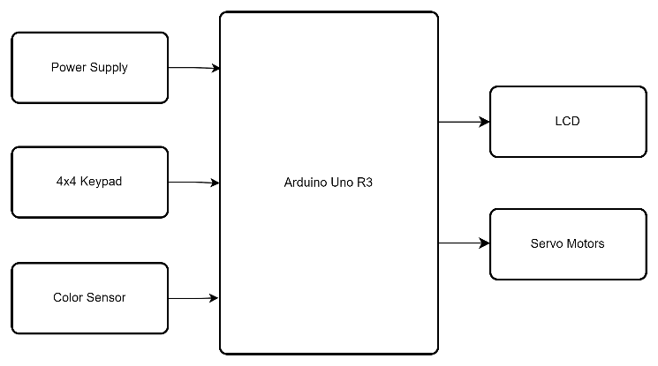

Fig. 1. Block Diagram for the Dual Mode Real-Time Cap Sorting System.

1. Software Development

Fig. 2 represents the proposed system’s flowchart. C++ program, which powers the majority of Arduino boards, is utilized in the proposed project. The development of the software for the real-time plastic bottle cap sorting machine follows a structured approach to ensure accuracy, efficiency, and ease of use. The Arduino Uno serves as the main controller, processing inputs from the color sensor and 4x4 keypad while managing outputs to the servo motors and LCD. The program is written in C++ using the Arduino IDE and structured into key modules for sensor reading, cap classification, motor control, and user interface. In automatic mode, the software continuously reads color sensor data, processes the detected color, and triggers the servo motor to direct the cap into the correct bin. In manual mode, the system responds to user inputs from the keypad, allowing manual sorting. The LCD module updates in real time to track the number of sorted caps per color. Error handling routines ensure that the machine operates smoothly, preventing misclassification and hardware conflicts. The software is tested through simulations and real-world trials to optimize performance and improve response time, ensuring a reliable and user-friendly sorting system.

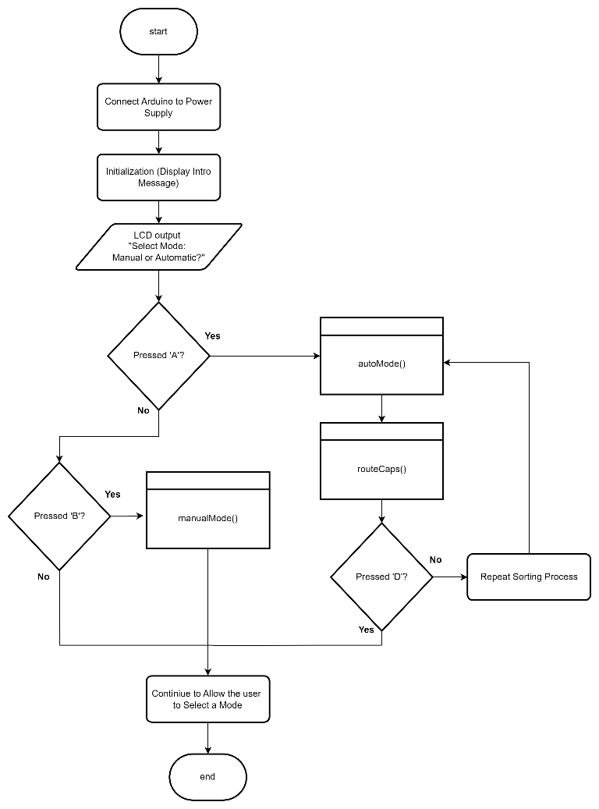

Fig. 2. Flowchart of the System.

1. Testing

To evaluate the performance and accuracy of the real-time plastic bottle cap sorting machine, a series of tests will be conducted under both automatic and manual modes. In automatic mode, the system will be tested by feeding plastic bottle caps of different colors into the storage area, where the servo motor will position each cap in front of the color sensor for identification. The system’s ability to correctly classify and direct each cap to the appropriate bin will be recorded. The sorting accuracy will be determined by comparing the number of correctly sorted caps to the total caps processed. In manual mode, a user will operate the sorting process using the 4x4 keypad, selecting the appropriate commands to sort caps, and the system's responsiveness to user input will be assessed. The LCD display's functionality will be verified by checking if it correctly tracks and updates the count of sorted caps in real time. Multiple trials will be conducted to identify possible errors, such as incorrect color detection or misplacement of caps. The results will help refine the system’s accuracy, speed, and efficiency, ensuring its reliability for small-scale recycling or educational purposes.

Fig. 3 The working prototype of the project is shown, including the complete system, internal circuit, and mechanism. It also displays the outputs on the LCD.

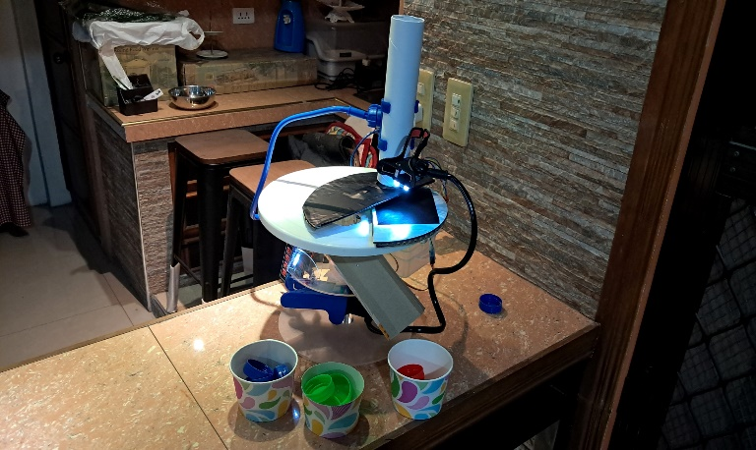

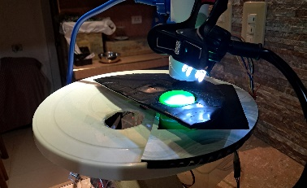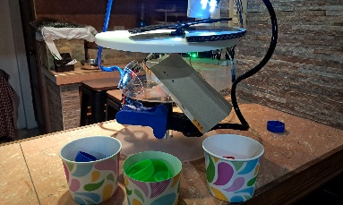

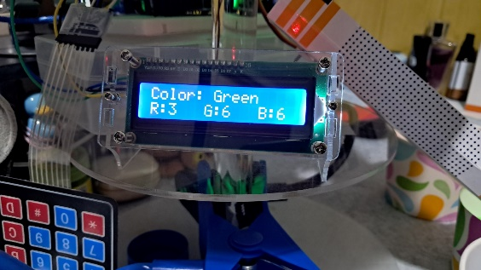

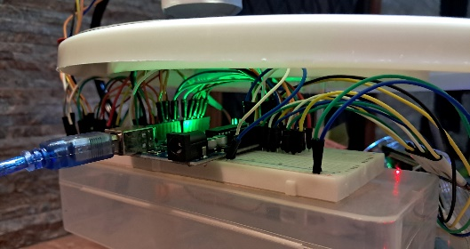

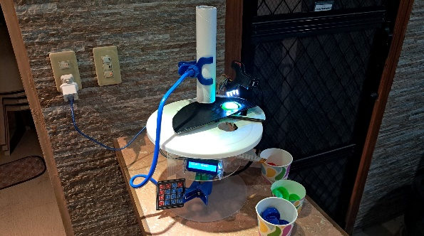

Fig. 3. Working Prototype of the Project with the Circuit.

For Fig. 4-6, Initialized variables and the setup of the two selection modes—one for automatic and one for manual — with continuous real-time updates of the count of sorted caps per color shown on the LCD. Configuration of the movement of the servo motors, managing outputs to the servo motors and processing inputs from the color sensor, and completed all functions to achieve project requirements.

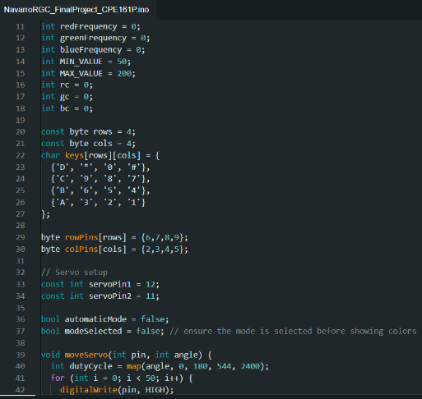

Fig. 4. Initialized Variables as well as the Setup of the Two Modes: One for Automatic Mode and another for Manual Mode, with Continuous Real-Time Updates of the Count of Sorted Caps per Color Shown on the LCD

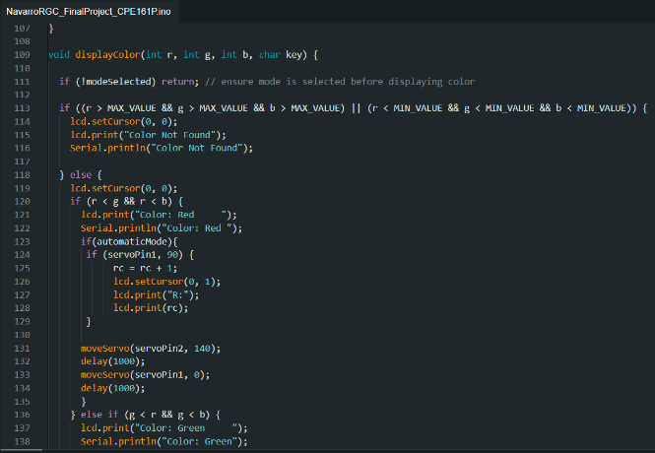

Fig. 5. Configuration of the Movements of the Servo Motors, Managing Outputs to the Servo Motors and Processing Inputs from the Color Sensor.

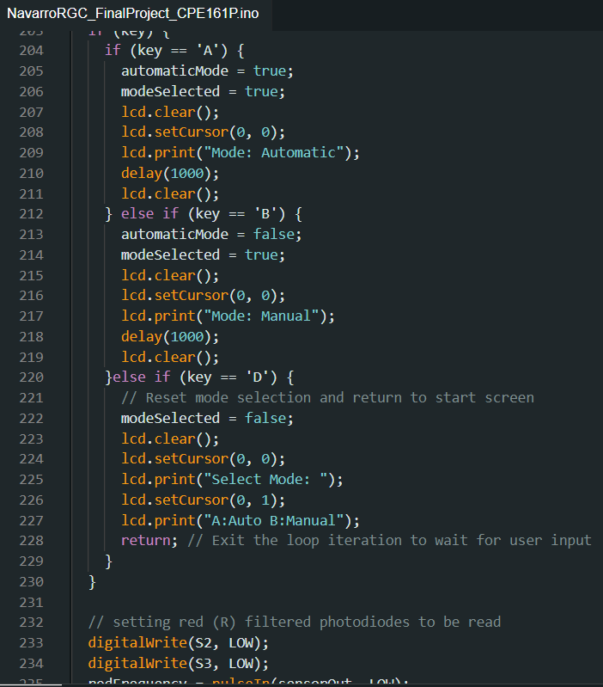

Fig. 6. Completing All the Functions Needed to Achieve All the Required Outputs of the Project.

1. Result and discussion

The real-time plastic bottle cap sorting machine successfully demonstrated the integration of automation and embedded systems in small-scale recycling. During testing, the system accurately classified plastic bottle caps based on color in both automatic and manual modes. In automatic mode, the color sensor efficiently detected the cap’s color, and the servo motors directed it to the correct bin with high precision. In manual mode, users-controlled sorting via the 4x4 keypad, allowing flexibility in operation. The LCD display accurately tracked and updated the number of sorted caps per color, ensuring real-time monitoring. Multiple trials confirmed the system’s reliability, with minimal errors in classification and placement. The servo motors operated smoothly, and the system promptly responded to sensor inputs and user commands. However, occasional misclassification occurred due to variations in lighting conditions affecting the color sensor’s accuracy. Adjustments in sensor calibration and environmental lighting conditions improved the overall performance. The successful implementation of this project highlights the practical application of embedded systems in waste management, demonstrating its potential for educational and small-scale recycling purposes.

1. Conclusion and recommendations

The development of the real-time plastic bottle cap sorting machine demonstrates the successful integration of automation and embedded systems in small-scale recycling. The system efficiently sorts bottle caps by color using an Arduino Uno, a color sensor, and servo motors, operating in both automatic and manual modes. The LCD display provides real-time tracking, improving user interaction and monitoring. However, to further enhance performance, future improvements should include:

1. A more advanced color sensor for higher accuracy, an optimized servo motor mechanism for faster sorting.
2. A larger storage capacity for increased efficiency.
3. Expanding the system to recognize different types of plastic materials could improve its applicability in recycling processes.
4. References

[1] D. Zhang, X. Zhang, and M. Zhou, “Automated sorting in industrial manufacturing: A review of technologies, challenges, and future directions,” IEEE Transactions on Automation Science and Engineering, vol. 18, no. 2, pp. 509-526, Apr. 2021.

[2] R. K. Gupta and A. Sharma, “Intelligent waste segregation using sensor-based sorting techniques,” IEEE Access, vol. 9, pp. 134762-134775, 2021.